**EXPERIMENT-12 VM**

VM IMAGE WITH HOS

STEP -1: Create a new Virtual Machine

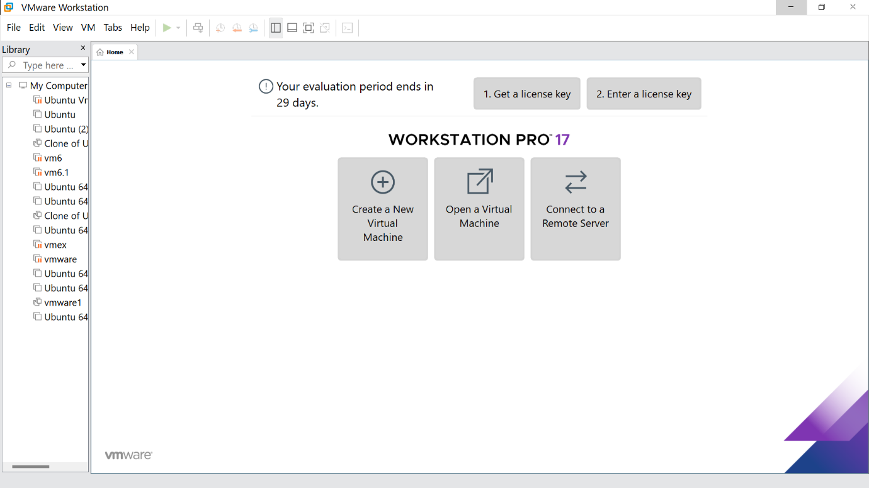

STEP -2: Click on Typical option and click Next

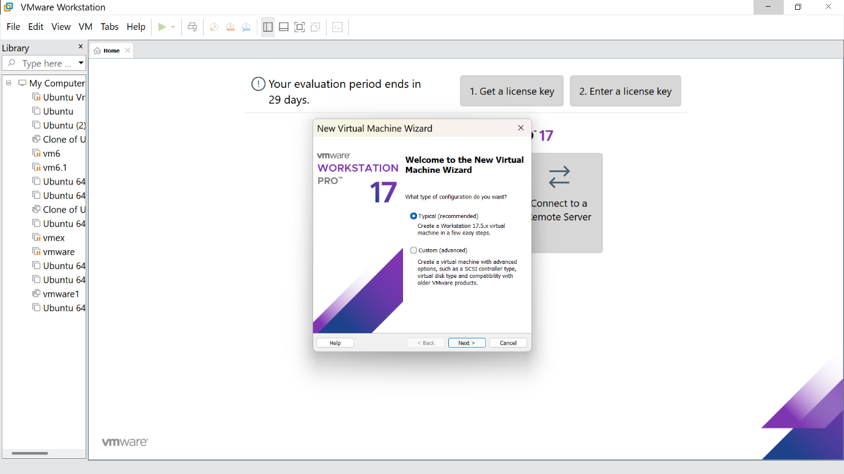

STEP -3: Click on install and browse the file you need and click next step

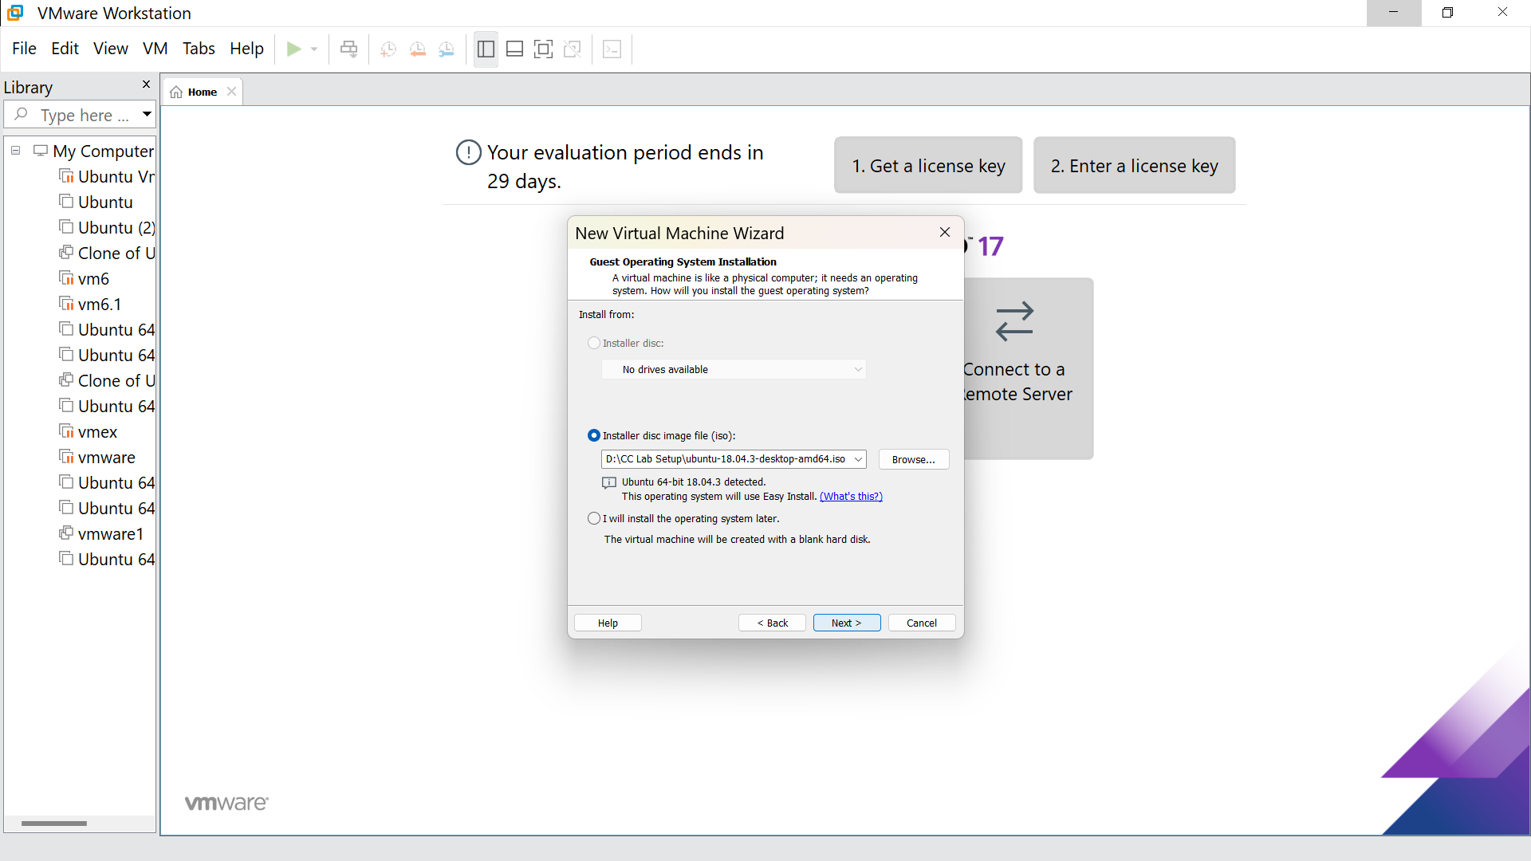

STEP -4: Fill the following details and click next

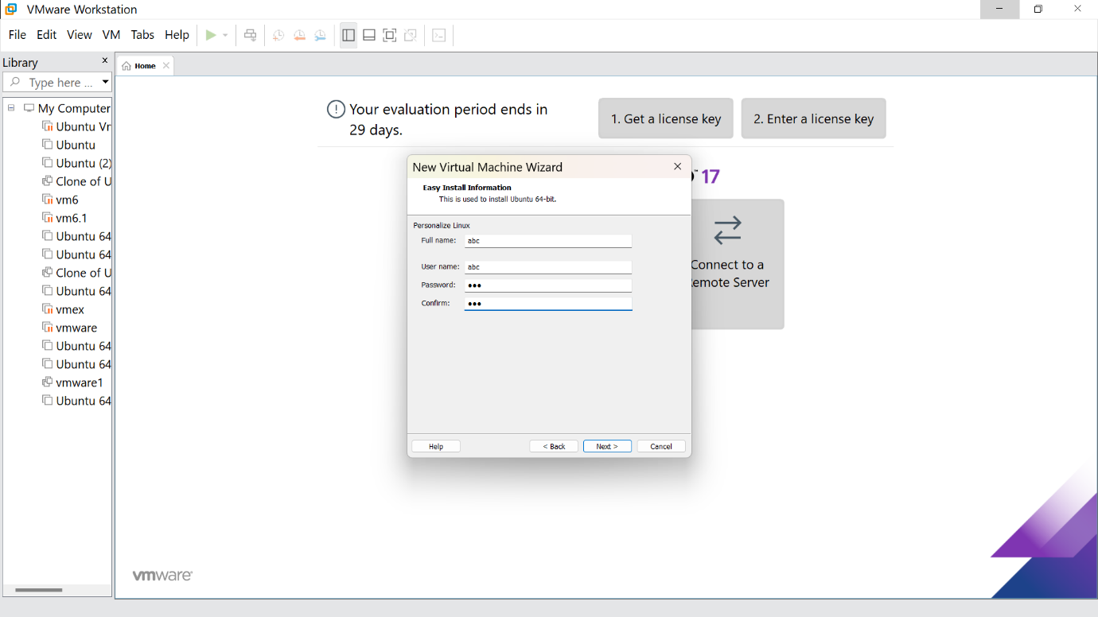

STEP -5: Give the virtual machine name( as your wish)

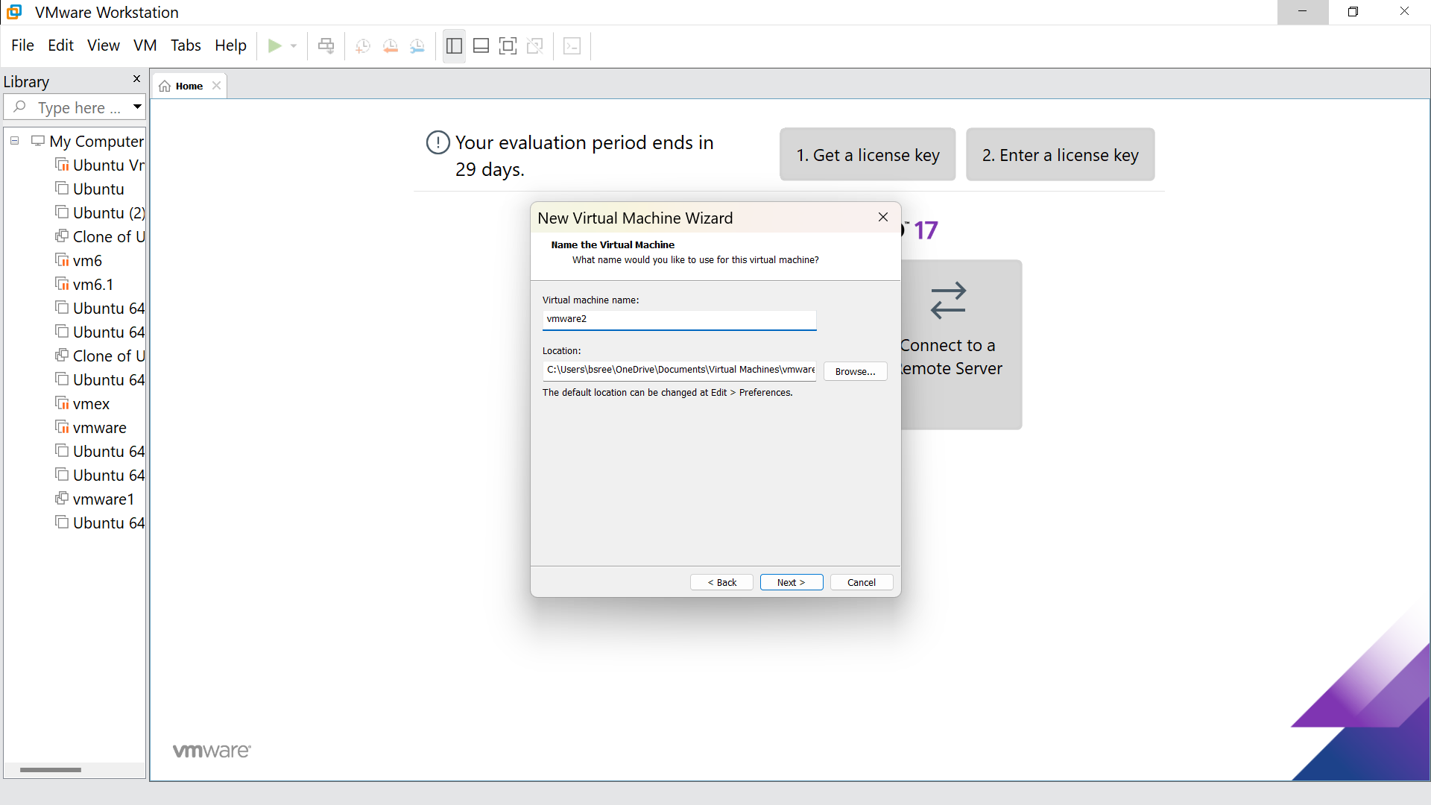

STEP -6: click on ‘store virtual disk as a single file’

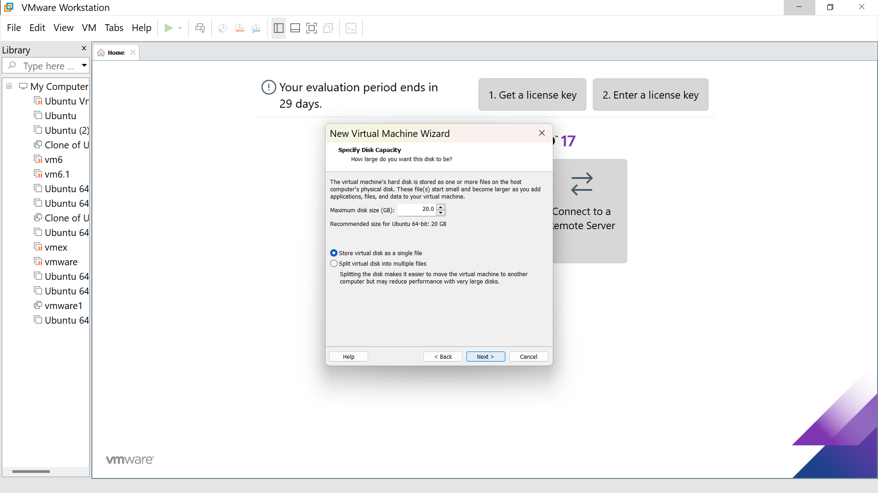

STEP -7: Click on finish

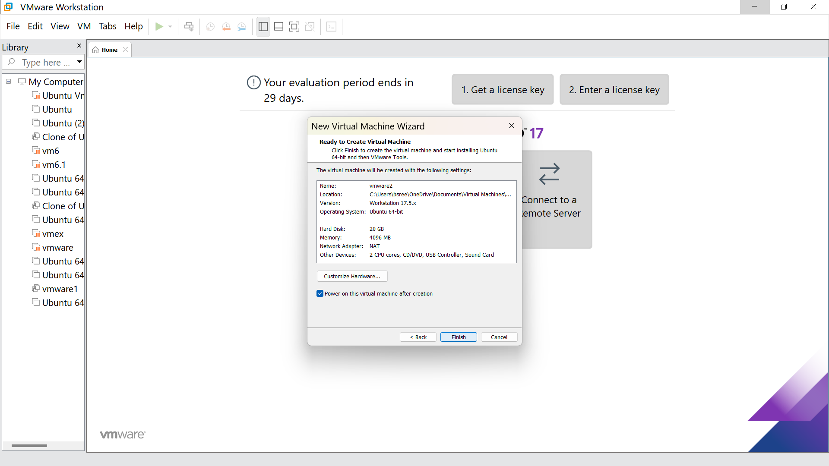

STEP -8: Hence we got the output

